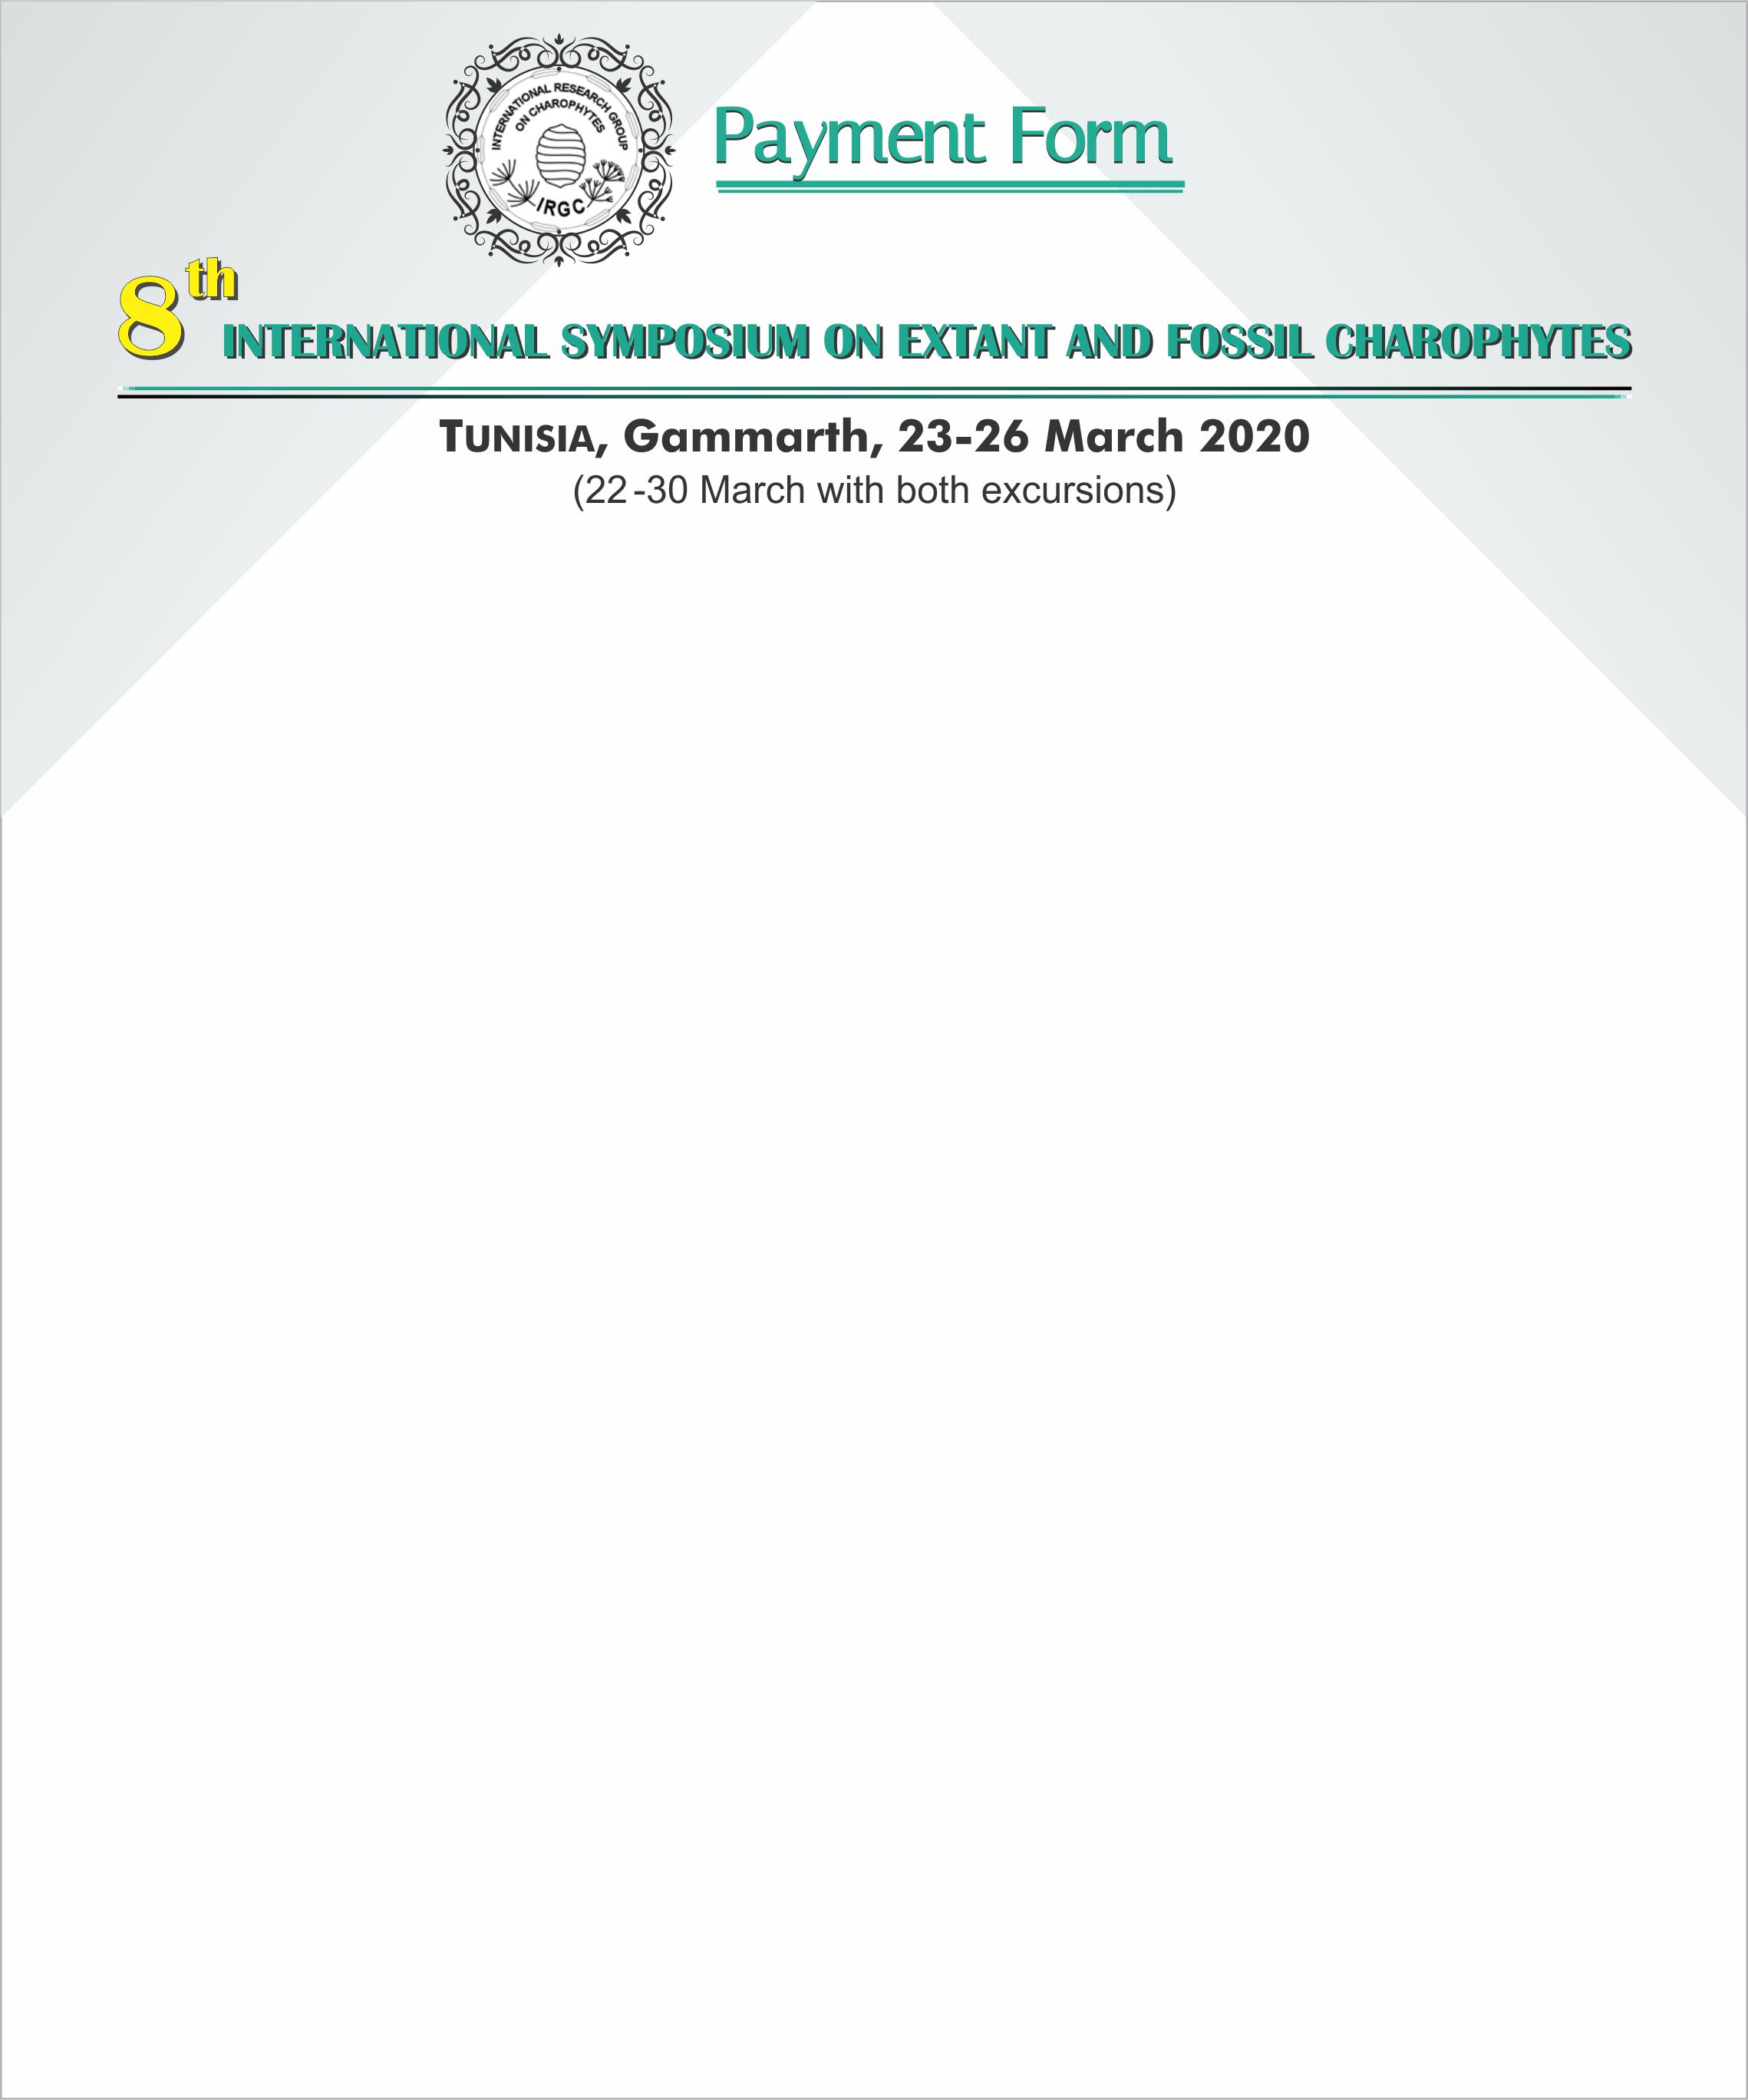

|  |  |  |
| --- | --- | --- |
| **NAME & SURNAME: …………………………………………………………………** | Y/N | FEES |
| **Full Symposium attendee** |  | 300 € |
| **Student** |  | 150 € |
| **Accompanied by**: name & surname …………………………………………………………………………………………………. |  | 100 € |
| **Field trip 1 (Ichkeul)** |  | 100 € |
| Number of persons........ |  | xxx |
| **Fieldtrip 2 (Central & South Tunisia)** |  | 300 € |
| **Number of persons….** |  | xxx |
| **Sub-total** | € | |

**ACCOMMODATION** at El Mouradi (All meals included)

|  |  |  |
| --- | --- | --- |
|  | **Number of days** | **Price** |
| **Single room** 70€/day. | from.................to............... ex **5 days** | *35O€* |
| **Double room** 110 €/day.  (shared with ...............................??........................ | from.................to............... | **xxxx** |
| **Additional night **:** | from.................to............... *ex. 29-30 March* | 70 € |
| **Sub-Total Accommodation:** | | ex 420 € |

**Total payments: …..**€

**Transferred to the ONM-Account: Date …….**

**\*\***If necessary, we can drop you directly at the airport TUC on 29/3 after the excursion.

Please return this form as soon as possible to:

Trabelsi Khaled : [trabkhalfss@gmail.com](mailto:trabkhalfss@gmail.com)

& Yassine Houla: [yassine.houla@onm.nat.tn](mailto:yassine.houla@onm.nat.tn)